PROGRAM NO:

DATE:

AIM Implement various validation in UI

Main Activity.xml

<?xml version="1.0" encoding="utf-8"?>  
<LinearLayout xmlns:android="http://schemas.android.com/apk/res/android"  
 android:layout_width="match_parent"  
 android:layout_height="wrap_content"  
 android:orientation="vertical"  
 android:padding="16dp"  
 android:background="#FFFFFF">  
  
 <!-- Title -->  
 <TextView  
 android:id="@+id/textView3"  
 android:layout_width="match_parent"  
 android:layout_height="wrap_content"  
 android:text="Registration Form"  
 android:textAlignment="center"  
 android:textColor="#D82020"  
 android:textSize="24sp"  
 android:layout_marginBottom="20dp" />  
  
 <!-- Name Field -->  
 <LinearLayout  
 android:layout_width="match_parent"  
 android:layout_height="wrap_content"  
 android:orientation="horizontal"  
 android:layout_marginBottom="10dp">  
  
 <TextView  
 android:id="@+id/textView4"  
 android:layout_width="120dp"  
 android:layout_height="wrap_content"  
 android:text="Name"  
 android:textSize="18sp"  
 android:layout_gravity="center_vertical" />  
  
 <EditText  
 android:id="@+id/name"  
 android:layout_width="0dp"  
 android:layout_height="wrap_content"  
 android:layout_weight="1"  
 android:inputType="text"  
 android:hint="Enter your name"  
 android:padding="10dp"/>  
 </LinearLayout>  
  
 <!-- Email Field -->  
 <LinearLayout  
 android:layout_width="match_parent"  
 android:layout_height="wrap_content"  
 android:orientation="horizontal"  
 android:layout_marginBottom="10dp">  
  
 <TextView  
 android:id="@+id/textView5"  
 android:layout_width="120dp"  
 android:layout_height="wrap_content"  
 android:text="Email"  
 android:textSize="18sp"  
 android:layout_gravity="center_vertical" />  
  
 <EditText  
 android:id="@+id/email"  
 android:layout_width="0dp"  
 android:layout_height="wrap_content"  
 android:layout_weight="1"  
 android:inputType="textEmailAddress"  
 android:hint="Enter your email"  
 android:padding="10dp"  
 />  
 </LinearLayout>  
  
 <!-- Password Field -->  
 <LinearLayout  
 android:layout_width="match_parent"  
 android:layout_height="wrap_content"  
 android:orientation="horizontal"  
 android:layout_marginBottom="10dp">  
  
 <TextView  
 android:id="@+id/textView6"  
 android:layout_width="120dp"  
 android:layout_height="wrap_content"  
 android:text="Password"  
 android:textSize="18sp"  
 android:layout_gravity="center_vertical" />  
  
 <EditText  
 android:id="@+id/password"  
 android:layout_width="0dp"  
 android:layout_height="wrap_content"  
 android:layout_weight="1"  
 android:inputType="textPassword"  
 android:hint="Enter your password"  
 android:padding="10dp" />  
 </LinearLayout>  
  
 <!-- Gender Field -->  
 <LinearLayout  
 android:layout_width="match_parent"  
 android:layout_height="wrap_content"  
 android:orientation="horizontal"  
 android:layout_marginBottom="10dp">  
  
 <TextView  
 android:id="@+id/gender_text"  
 android:layout_width="120dp"  
 android:layout_height="wrap_content"  
 android:text="Gender"  
 android:textSize="18sp"  
 android:layout_gravity="center_vertical" />  
  
 <RadioGroup  
 android:id="@+id/gender"  
 android:layout_width="match_parent"  
 android:layout_height="wrap_content"  
 android:orientation="horizontal">  
  
 <RadioButton  
 android:id="@+id/female"  
 android:layout_width="wrap_content"  
 android:layout_height="wrap_content"  
 android:text="Female" />  
  
 <RadioButton  
 android:id="@+id/male"  
 android:layout_width="wrap_content"  
 android:layout_height="wrap_content"  
 android:text="Male" />  
 </RadioGroup>  
 </LinearLayout>  
  
 <!-- Terms Checkbox -->  
 <CheckBox  
 android:id="@+id/checkBox"  
 android:layout_width="wrap_content"  
 android:layout_height="wrap_content"  
 android:text="I agree to the Terms Conditions"  
 android:layout_marginBottom="20dp" />  
  
 <!-- Submit Button -->  
 <Button  
 android:id="@+id/button"  
 android:layout_width="match_parent"  
 android:layout_height="wrap_content"  
 android:text="Submit"  
 android:backgroundTint="#D82020"  
 android:textColor="#FFFFFF"  
 android:onClick="onClickSubmit" />  
</LinearLayout>

Java

package com.example.registration;  
  
import android.os.Bundle;  
import android.text.TextUtils;  
import android.view.View;  
import android.widget.Button;  
import android.widget.CheckBox;  
import android.widget.EditText;  
import android.widget.RadioButton;  
import android.widget.RadioGroup;  
import android.widget.Toast;  
import androidx.appcompat.app.AppCompatActivity;  
  
public class MainActivity extends AppCompatActivity {  
  
 private EditText nameEditText, emailEditText, passwordEditText;  
 private RadioGroup genderRadioGroup;  
 private CheckBox termsCheckBox;  
 private Button submitButton;  
  
 @Override  
 protected void onCreate(Bundle savedInstanceState) {  
 super.onCreate(savedInstanceState);  
 setContentView(R.layout.*activity_main*);  
  
 // Initialize UI elements  
 nameEditText = findViewById(R.id.*name*);  
 emailEditText = findViewById(R.id.*email*);  
 passwordEditText = findViewById(R.id.*password*);  
 genderRadioGroup = findViewById(R.id.*gender*);  
 termsCheckBox = findViewById(R.id.*checkBox*);  
 submitButton = findViewById(R.id.*button*);  
  
 // Set submit button listener  
 submitButton.setOnClickListener(new View.OnClickListener() {  
 @Override  
 public void onClick(View v) {  
 validateForm();  
 }  
 });  
 }  
  
 private void validateForm() {  
 // Get user input  
 String name = nameEditText.getText().toString().trim();  
 String email = emailEditText.getText().toString().trim();  
 String password = passwordEditText.getText().toString().trim();  
 int selectedGenderId = genderRadioGroup.getCheckedRadioButtonId();  
  
 // Check if name is empty  
 if (TextUtils.*isEmpty*(name)) {  
 nameEditText.setError("Name is required");  
 nameEditText.requestFocus();  
 return;  
 }  
  
 // Check if email is empty or invalid  
 if (TextUtils.*isEmpty*(email)) {  
 emailEditText.setError("Email is required");  
 emailEditText.requestFocus();  
 return;  
 } else if (!isValidEmail(email)) {  
 emailEditText.setError("Enter a valid email");  
 emailEditText.requestFocus();  
 return;  
 }  
  
 // Check if password is empty or less than 6 characters  
 if (TextUtils.*isEmpty*(password)) {  
 passwordEditText.setError("Password is required");  
 passwordEditText.requestFocus();  
 return;  
 } else if (password.length() < 6) {  
 passwordEditText.setError("Password must be at least 6 characters long");  
 passwordEditText.requestFocus();  
 return;  
 }  
  
 // Check if gender is selected  
 if (selectedGenderId == -1) {  
 Toast.*makeText*(MainActivity.this, "Please select your gender", Toast.*LENGTH_SHORT*).show();  
 return;  
 }  
  
 // Check if terms checkbox is checked  
 if (!termsCheckBox.isChecked()) {  
 Toast.*makeText*(MainActivity.this, "You must agree to the Terms and Conditions", Toast.*LENGTH_SHORT*).show();  
 return;  
 }  
  
 // If all validations pass, show success message  
 Toast.*makeText*(MainActivity.this, "Registration Successful", Toast.*LENGTH_SHORT*).show();  
 }  
  
 // Validate email format using a regex pattern  
 private boolean isValidEmail(String email) {  
 return android.util.Patterns.*EMAIL_ADDRESS*.matcher(email).matches();  
 }  
}

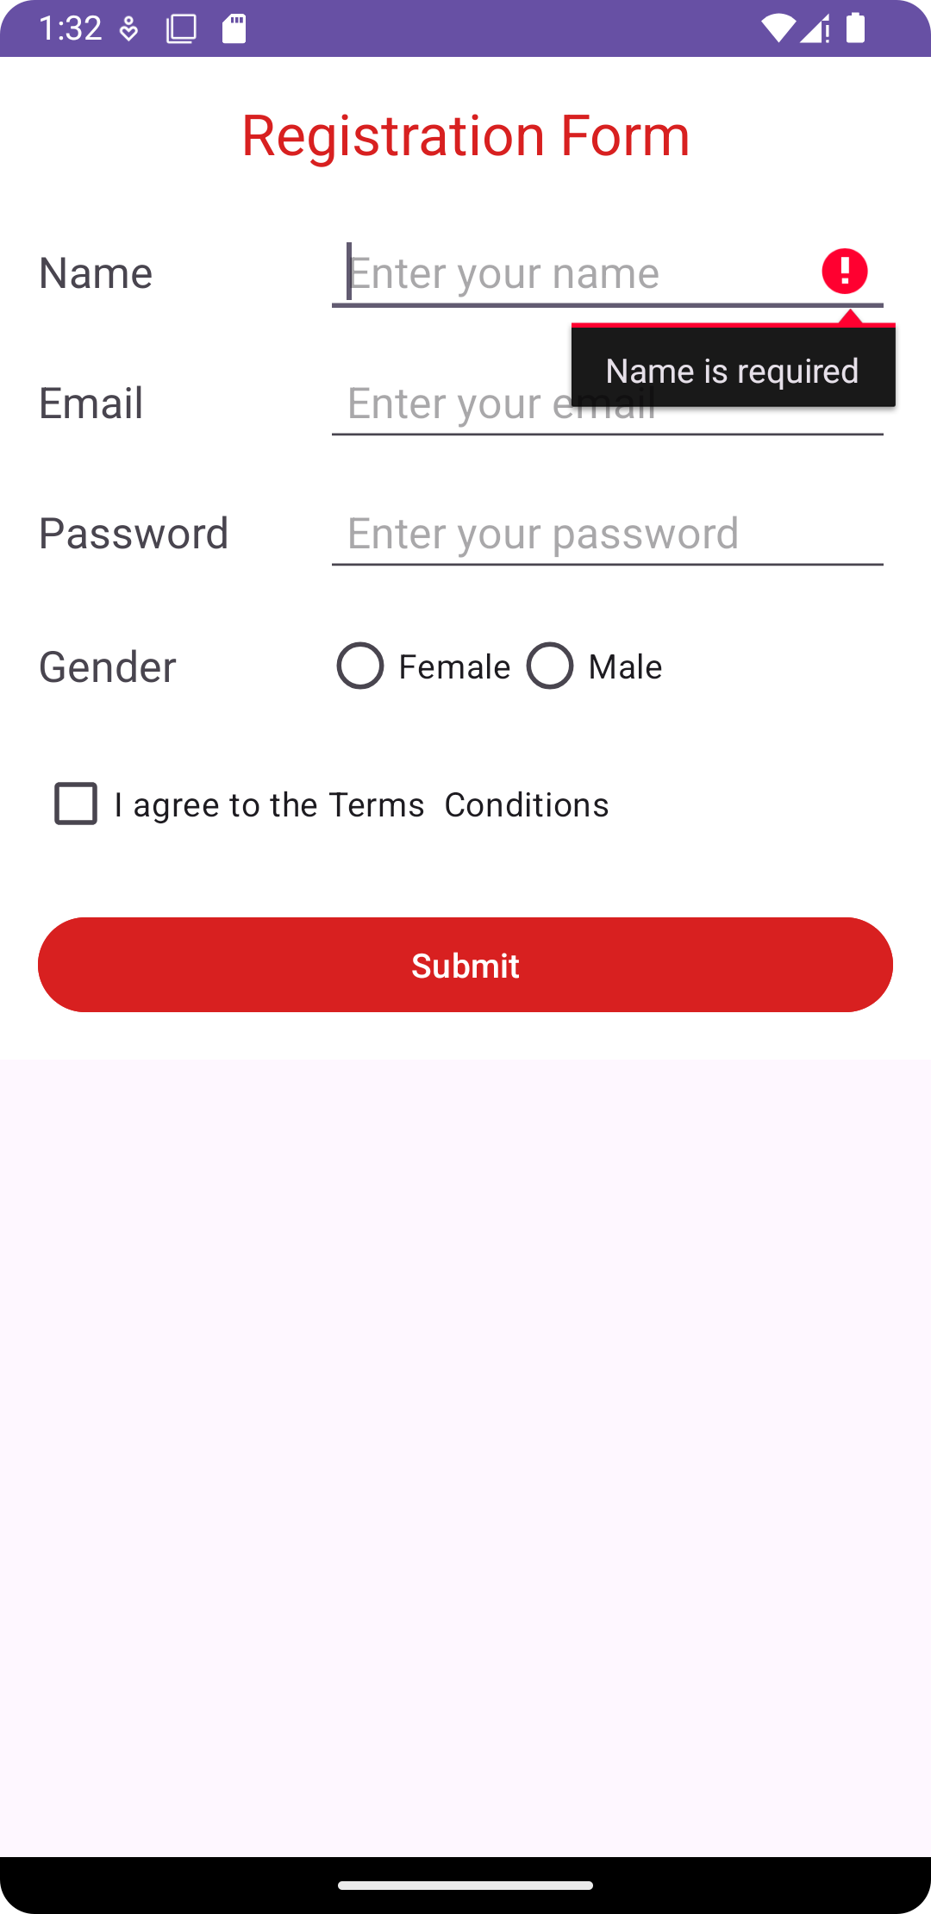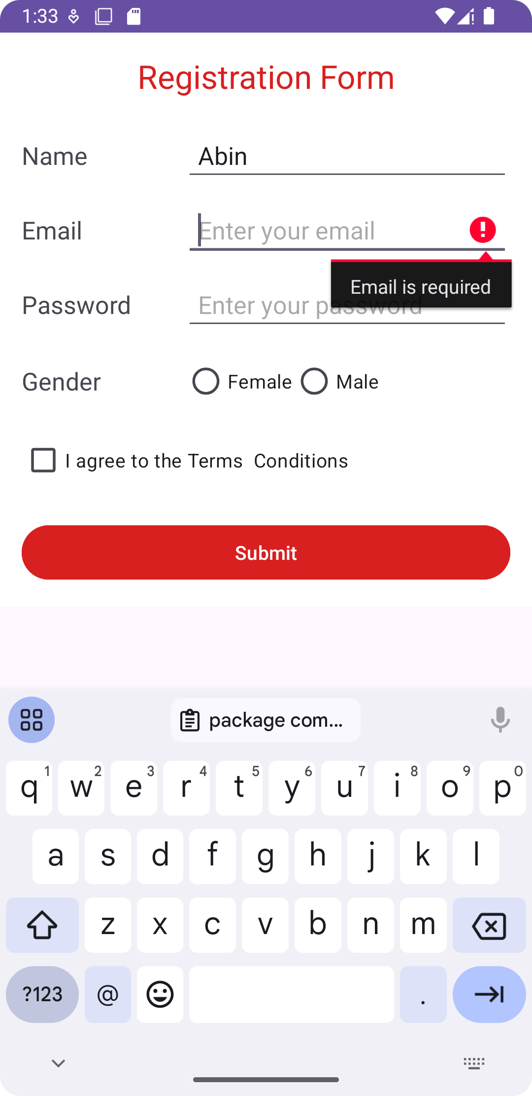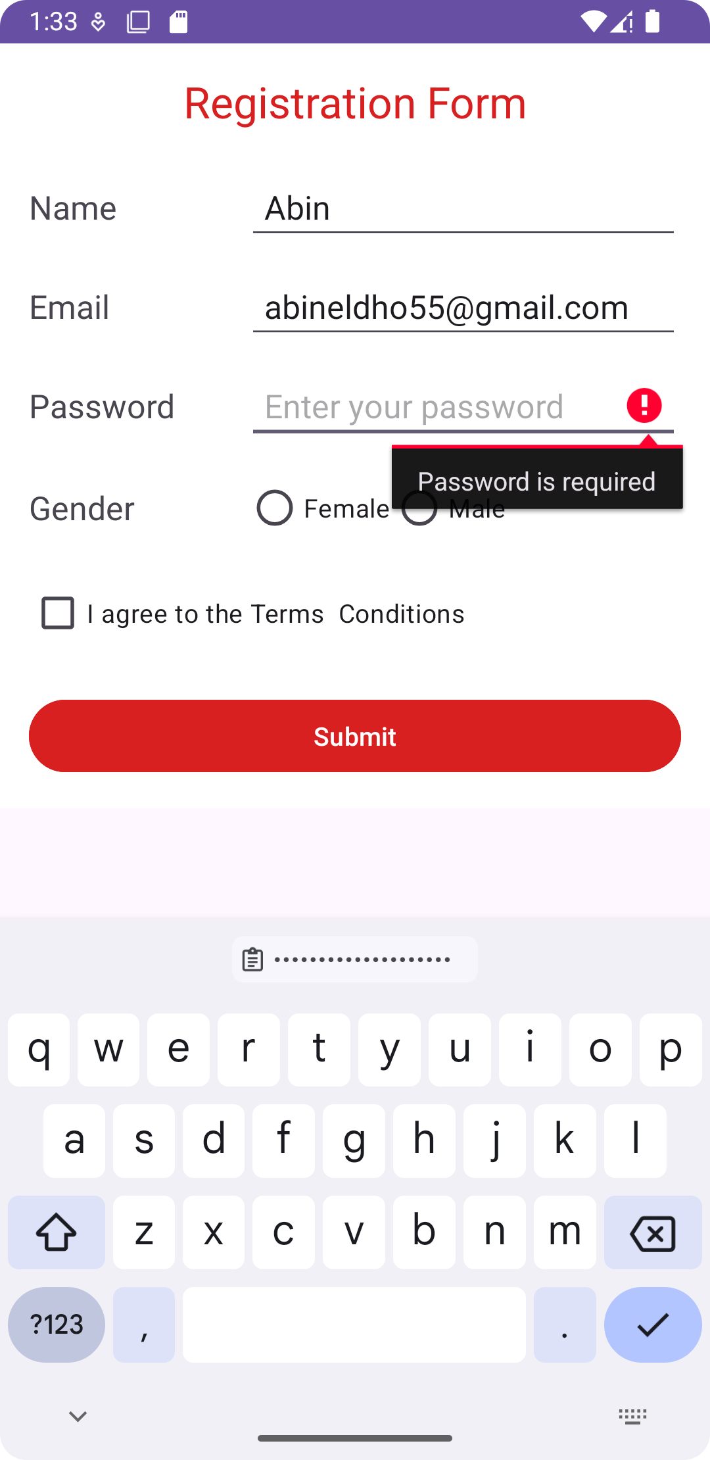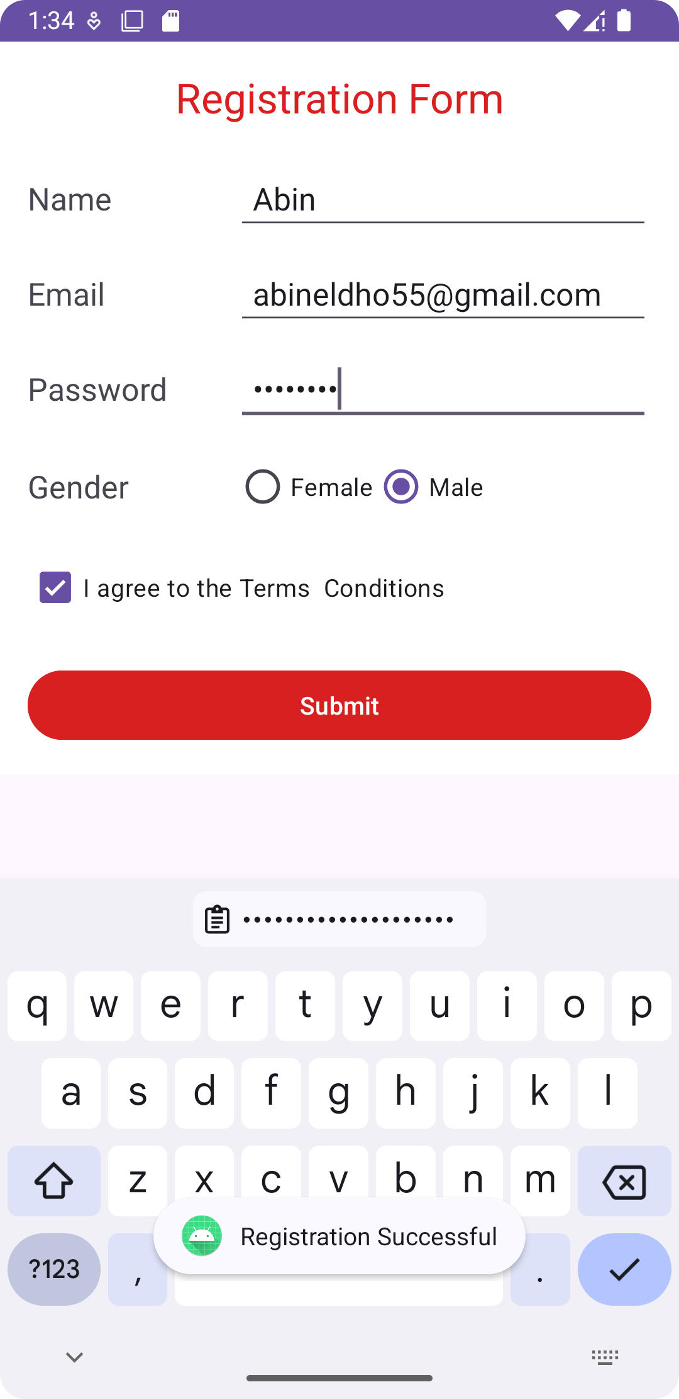

PROGRAM NO:

DATE:

AIM Design a Registration activity and store registration details in local memory of phone using intents and shared perferences.

Main activity.xml

<?xml version="1.0" encoding="utf-8"?>  
<LinearLayout xmlns:android="http://schemas.android.com/apk/res/android"  
 android:layout_width="match_parent"  
 android:layout_height="wrap_content"  
 android:orientation="vertical"  
 android:padding="16dp"  
 android:background="#FFFFFF">  
  
  
 <TextView  
 android:id="@+id/textView3"  
 android:layout_width="match_parent"  
 android:layout_height="wrap_content"  
 android:text="Registration Form"  
 android:textAlignment="center"  
 android:textColor="#D82020"  
 android:textSize="24sp"  
 android:layout_marginBottom="20dp" />  
  
  
 <LinearLayout  
 android:layout_width="match_parent"  
 android:layout_height="wrap_content"  
 android:orientation="horizontal"  
 android:layout_marginBottom="10dp">  
  
 <TextView  
 android:id="@+id/textView4"  
 android:layout_width="120dp"  
 android:layout_height="wrap_content"  
 android:text="Name"  
 android:textSize="18sp"  
 android:layout_gravity="center_vertical" />  
  
 <EditText  
 android:id="@+id/name"  
 android:layout_width="0dp"  
 android:layout_height="wrap_content"  
 android:layout_weight="1"  
 android:inputType="text"  
 android:hint="Enter your name"  
 android:padding="10dp"/>  
 </LinearLayout>  
  
  
 <LinearLayout  
 android:layout_width="match_parent"  
 android:layout_height="wrap_content"  
 android:orientation="horizontal"  
 android:layout_marginBottom="10dp">  
  
 <TextView  
 android:id="@+id/textView5"  
 android:layout_width="120dp"  
 android:layout_height="wrap_content"  
 android:text="Email"  
 android:textSize="18sp"  
 android:layout_gravity="center_vertical" />  
  
 <EditText  
 android:id="@+id/email"  
 android:layout_width="0dp"  
 android:layout_height="wrap_content"  
 android:layout_weight="1"  
 android:inputType="textEmailAddress"  
 android:hint="Enter your email"  
 android:padding="10dp"  
 />  
 </LinearLayout>  
  
 <LinearLayout  
 android:layout_width="match_parent"  
 android:layout_height="wrap_content"  
 android:orientation="horizontal"  
 android:layout_marginBottom="10dp">  
  
 <TextView  
 android:id="@+id/textView6"  
 android:layout_width="120dp"  
 android:layout_height="wrap_content"  
 android:text="Password"  
 android:textSize="18sp"  
 android:layout_gravity="center_vertical" />  
  
 <EditText  
 android:id="@+id/password"  
 android:layout_width="0dp"  
 android:layout_height="wrap_content"  
 android:layout_weight="1"  
 android:inputType="textPassword"  
 android:hint="Enter your password"  
 android:padding="10dp" />  
 </LinearLayout>  
  
 <LinearLayout  
 android:layout_width="match_parent"  
 android:layout_height="wrap_content"  
 android:orientation="horizontal"  
 android:layout_marginBottom="10dp">  
  
 <TextView  
 android:id="@+id/gender_text"  
 android:layout_width="120dp"  
 android:layout_height="wrap_content"  
 android:text="Gender"  
 android:textSize="18sp"  
 android:layout_gravity="center_vertical" />  
  
 <RadioGroup  
 android:id="@+id/gender"  
 android:layout_width="match_parent"  
 android:layout_height="wrap_content"  
 android:orientation="horizontal">  
  
 <RadioButton  
 android:id="@+id/female"  
 android:layout_width="wrap_content"  
 android:layout_height="wrap_content"  
 android:text="Female" />  
  
 <RadioButton  
 android:id="@+id/male"  
 android:layout_width="wrap_content"  
 android:layout_height="wrap_content"  
 android:text="Male" />  
 </RadioGroup>  
 </LinearLayout>  
  
 <CheckBox  
 android:id="@+id/checkBox"  
 android:layout_width="wrap_content"  
 android:layout_height="wrap_content"  
 android:text="I agree to the Terms Conditions"  
 android:layout_marginBottom="20dp" />  
  
  
 <Button  
 android:id="@+id/button"  
 android:layout_width="match_parent"  
 android:layout_height="wrap_content"  
 android:text="Submit"  
 android:backgroundTint="#D82020"  
 android:textColor="#FFFFFF"  
 android:onClick="onClickSubmit" />  
</LinearLayout>

**Java activity**

package com.example.registrationform;  
  
import android.content.Context;  
import android.content.Intent;  
import android.content.SharedPreferences;  
import android.os.Bundle;  
import android.text.TextUtils;  
import android.view.View;  
import android.widget.Button;  
import android.widget.CheckBox;  
import android.widget.EditText;  
import android.widget.RadioButton;  
import android.widget.RadioGroup;  
import android.widget.Toast;  
  
import androidx.appcompat.app.AppCompatActivity;  
  
public class MainActivity extends AppCompatActivity {  
  
 EditText nameEditText, emailEditText, passwordEditText;  
 RadioGroup genderRadioGroup;  
 CheckBox termsCheckBox;  
 Button submitButton;  
  
 SharedPreferences sharedPreferences;  
  
 @Override  
 protected void onCreate(Bundle savedInstanceState) {  
 super.onCreate(savedInstanceState);  
 setContentView(R.layout.*activity_main*);  
  
 // Initialize views  
 nameEditText = findViewById(R.id.*name*);  
 emailEditText = findViewById(R.id.*email*);  
 passwordEditText = findViewById(R.id.*password*);  
 genderRadioGroup = findViewById(R.id.*gender*);  
 termsCheckBox = findViewById(R.id.*checkBox*);  
 submitButton = findViewById(R.id.*button*);  
  
 // Initialize SharedPreferences  
 sharedPreferences = getSharedPreferences("UserPrefs", Context.*MODE_PRIVATE*);  
  
 // Set up the submit button listener  
 submitButton.setOnClickListener(new View.OnClickListener() {  
 @Override  
 public void onClick(View v) {  
 // Get user inputs  
 String name = nameEditText.getText().toString();  
 String email = emailEditText.getText().toString();  
 String password = passwordEditText.getText().toString();  
 int selectedGenderId = genderRadioGroup.getCheckedRadioButtonId();  
 RadioButton selectedGender = findViewById(selectedGenderId);  
 String gender = (selectedGender != null) ? selectedGender.getText().toString() : "";  
  
 // Validate inputs  
 if (TextUtils.*isEmpty*(name) || TextUtils.*isEmpty*(email) || TextUtils.*isEmpty*(password) || TextUtils.*isEmpty*(gender)) {  
 Toast.*makeText*(MainActivity.this, "Please fill all fields", Toast.*LENGTH_SHORT*).show();  
 return;  
 }  
  
 if (!termsCheckBox.isChecked()) {  
 Toast.*makeText*(MainActivity.this, "You must agree to the terms and conditions", Toast.*LENGTH_SHORT*).show();  
 return;  
 }  
  
 // Save data in SharedPreferences  
 SharedPreferences.Editor editor = sharedPreferences.edit();  
 editor.putString("Name", name);  
 editor.putString("Email", email);  
 editor.putString("Password", password);  
 editor.putString("Gender", gender);  
 editor.apply(); // Save changes  
  
 // Start new activity and pass data using Intent  
 Intent intent = new Intent(MainActivity.this, userdetails.class);  
 startActivity(intent);  
 }  
 });  
 }  
}

**user details activity.xml**

<?xml version="1.0" encoding="utf-8"?>  
<LinearLayout xmlns:android="http://schemas.android.com/apk/res/android"  
 android:layout_width="match_parent"  
 android:layout_height="wrap_content"  
 android:orientation="vertical"  
 android:padding="16dp">  
  
 <TextView  
 android:id="@+id/nameTextView"  
 android:layout_width="wrap_content"  
 android:layout_height="wrap_content"  
 android:text="Name"  
 android:textSize="18sp" />  
  
 <TextView  
 android:id="@+id/emailTextView"  
 android:layout_width="wrap_content"  
 android:layout_height="wrap_content"  
 android:text="Email"  
 android:textSize="18sp"  
 android:layout_marginTop="10dp" />  
  
 <TextView  
 android:id="@+id/genderTextView"  
 android:layout_width="wrap_content"  
 android:layout_height="wrap_content"  
 android:text="Gender"  
 android:textSize="18sp"  
 android:layout_marginTop="10dp" />  
</LinearLayout>

**User activity java**

package com.example.registrationform;  
  
import android.content.SharedPreferences;  
import android.os.Bundle;  
import android.widget.TextView;  
  
import androidx.appcompat.app.AppCompatActivity;  
  
public class userdetails extends AppCompatActivity {  
  
 TextView nameTextView, emailTextView, genderTextView;  
  
 SharedPreferences sharedPreferences;  
  
 @Override  
 protected void onCreate(Bundle savedInstanceState) {  
 super.onCreate(savedInstanceState);  
 setContentView(R.layout.*activity_userdetails*);  
  
 // Initialize views  
 nameTextView = findViewById(R.id.*nameTextView*);  
 emailTextView = findViewById(R.id.*emailTextView*);  
 genderTextView = findViewById(R.id.*genderTextView*);  
  
 // Retrieve data from SharedPreferences  
 sharedPreferences = getSharedPreferences("UserPrefs", *MODE_PRIVATE*);  
 String name = sharedPreferences.getString("Name", "N/A");  
 String email = sharedPreferences.getString("Email", "N/A");  
 String gender = sharedPreferences.getString("Gender", "N/A");  
  
 // Set data in TextViews  
 nameTextView.setText("Name: " + name);  
 emailTextView.setText("Email: " + email);  
 genderTextView.setText("Gender: " + gender);  
 }  
}

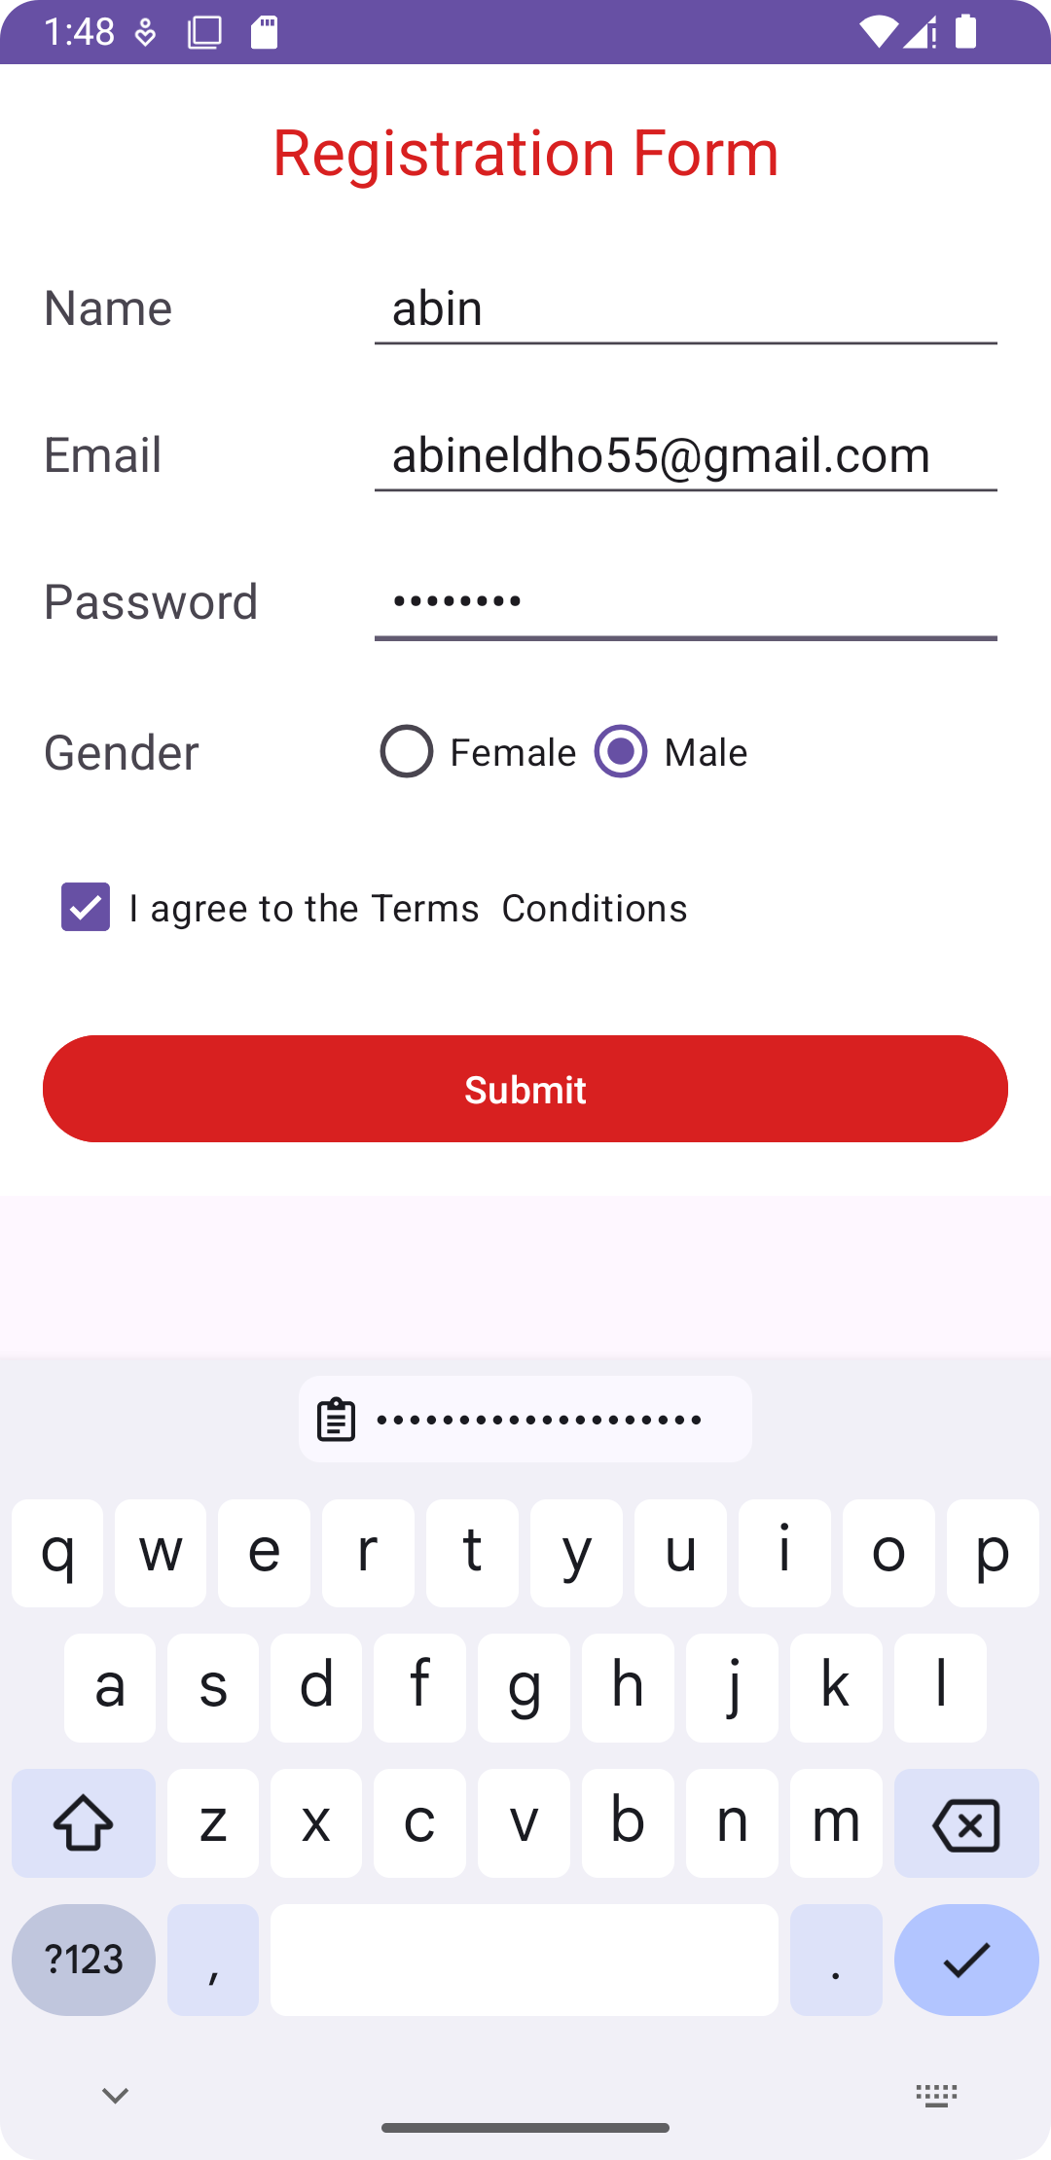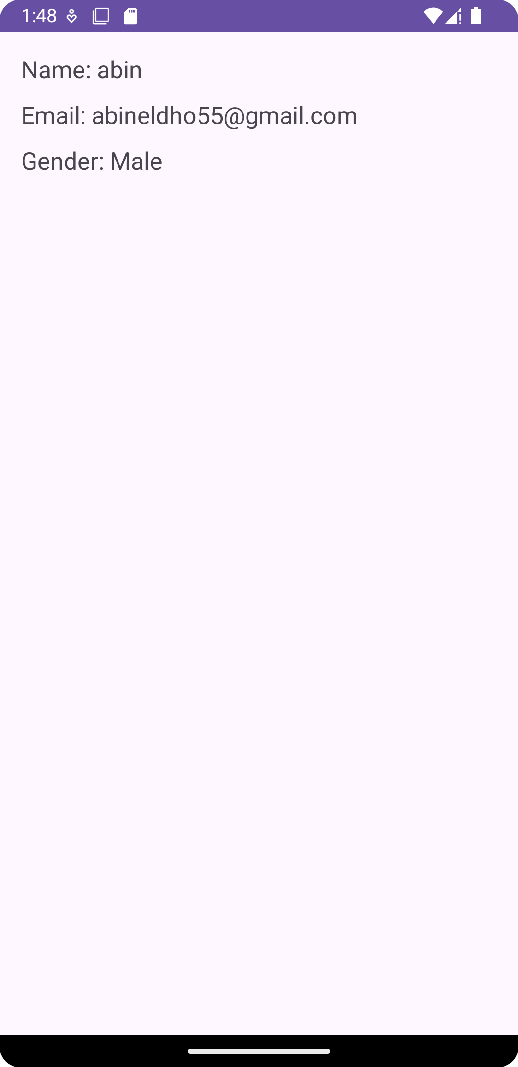

PROGRAM NO:

DATE:

AIM Design a simple Calculator using Grid Layout and Cascaded Linear Layout

Mainactivity.xml

<?xml version="1.0" encoding="utf-8"?>  
<LinearLayout xmlns:android="http://schemas.android.com/apk/res/android"  
 android:layout_width="match_parent"  
 android:layout_height="match_parent"  
 android:orientation="vertical"  
 android:padding="16dp">  
  
 <!-- Display TextView -->  
 <TextView  
 android:id="@+id/display"  
 android:layout_width="match_parent"  
 android:layout_height="wrap_content"  
 android:textSize="32sp"  
 android:background="#E0E0E0"  
 android:padding="16dp"  
 android:gravity="end"  
 android:text="" />  
  
 <!-- Grid for Calculator Buttons -->  
 <GridLayout  
 android:layout_width="match_parent"  
 android:layout_height="wrap_content"  
 android:rowCount="5"  
 android:columnCount="4">  
  
 <!-- First Row -->  
 <Button android:text="1" android:onClick="onNumberClick" />  
 <Button android:text="2" android:onClick="onNumberClick" />  
 <Button android:text="3" android:onClick="onNumberClick" />  
 <Button android:text="+" android:onClick="onOperationClick" />  
  
 <!-- Second Row -->  
 <Button android:text="4" android:onClick="onNumberClick" />  
 <Button android:text="5" android:onClick="onNumberClick" />  
 <Button android:text="6" android:onClick="onNumberClick" />  
 <Button android:text="-" android:onClick="onOperationClick" />  
  
 <!-- Third Row -->  
 <Button android:text="7" android:onClick="onNumberClick" />  
 <Button android:text="8" android:onClick="onNumberClick" />  
 <Button android:text="9" android:onClick="onNumberClick" />  
 <Button android:text="*" android:onClick="onOperationClick" />  
  
 <!-- Fourth Row -->  
 <Button android:text="C" android:onClick="onClearClick" />  
 <Button android:text="0" android:onClick="onNumberClick" />  
 <Button android:text="=" android:onClick="onEqualClick" />  
 <Button android:text="/" android:onClick="onOperationClick" />  
  
 </GridLayout>  
</LinearLayout>

Java ctivity

package com.example.calculator;  
  
import android.os.Bundle;  
import android.view.View;  
import android.widget.Button;  
import android.widget.TextView;  
import androidx.appcompat.app.AppCompatActivity;  
  
public class MainActivity extends AppCompatActivity {  
  
 private TextView display;  
 private StringBuilder input; // To handle input dynamically  
 private String operation;  
 private double firstOperand;  
  
 @Override  
 protected void onCreate(Bundle savedInstanceState) {  
 super.onCreate(savedInstanceState);  
 setContentView(R.layout.*activity_main*);  
  
  
 display = findViewById(R.id.*display*);  
 input = new StringBuilder();  
 }  
  
  
 public void onNumberClick(View view) {  
 Button button = (Button) view;  
 input.append(button.getText());  
 display.setText(input.toString());  
 }  
  
  
 public void onOperationClick(View view) {  
 if (input.length() > 0) {  
 firstOperand = Double.*parseDouble*(input.toString());  
 operation = ((Button) view).getText().toString();  
 input.setLength(0);  
 display.setText(operation);  
 }  
 }  
  
  
 public void onEqualClick(View view) {  
 if (input.length() > 0 && operation != null) {  
 double secondOperand = Double.*parseDouble*(input.toString());  
 double result = 0;  
  
  
 switch (operation) {  
 case "+":  
 result = firstOperand + secondOperand;  
 break;  
 case "-":  
 result = firstOperand - secondOperand;  
 break;  
 case "*":  
 result = firstOperand * secondOperand;  
 break;  
 case "/":  
 if (secondOperand != 0) {  
 result = firstOperand / secondOperand;  
 } else {  
 display.setText("Error");  
 return;  
 }  
 break;  
 }  
  
 display.setText(String.*valueOf*(result));  
 input.setLength(0);  
 operation = null;  
 }  
 }  
  
  
 public void onClearClick(View view) {  
 input.setLength(0);  
 display.setText("");  
 operation = null;  
 firstOperand = 0;  
 }  
}

output

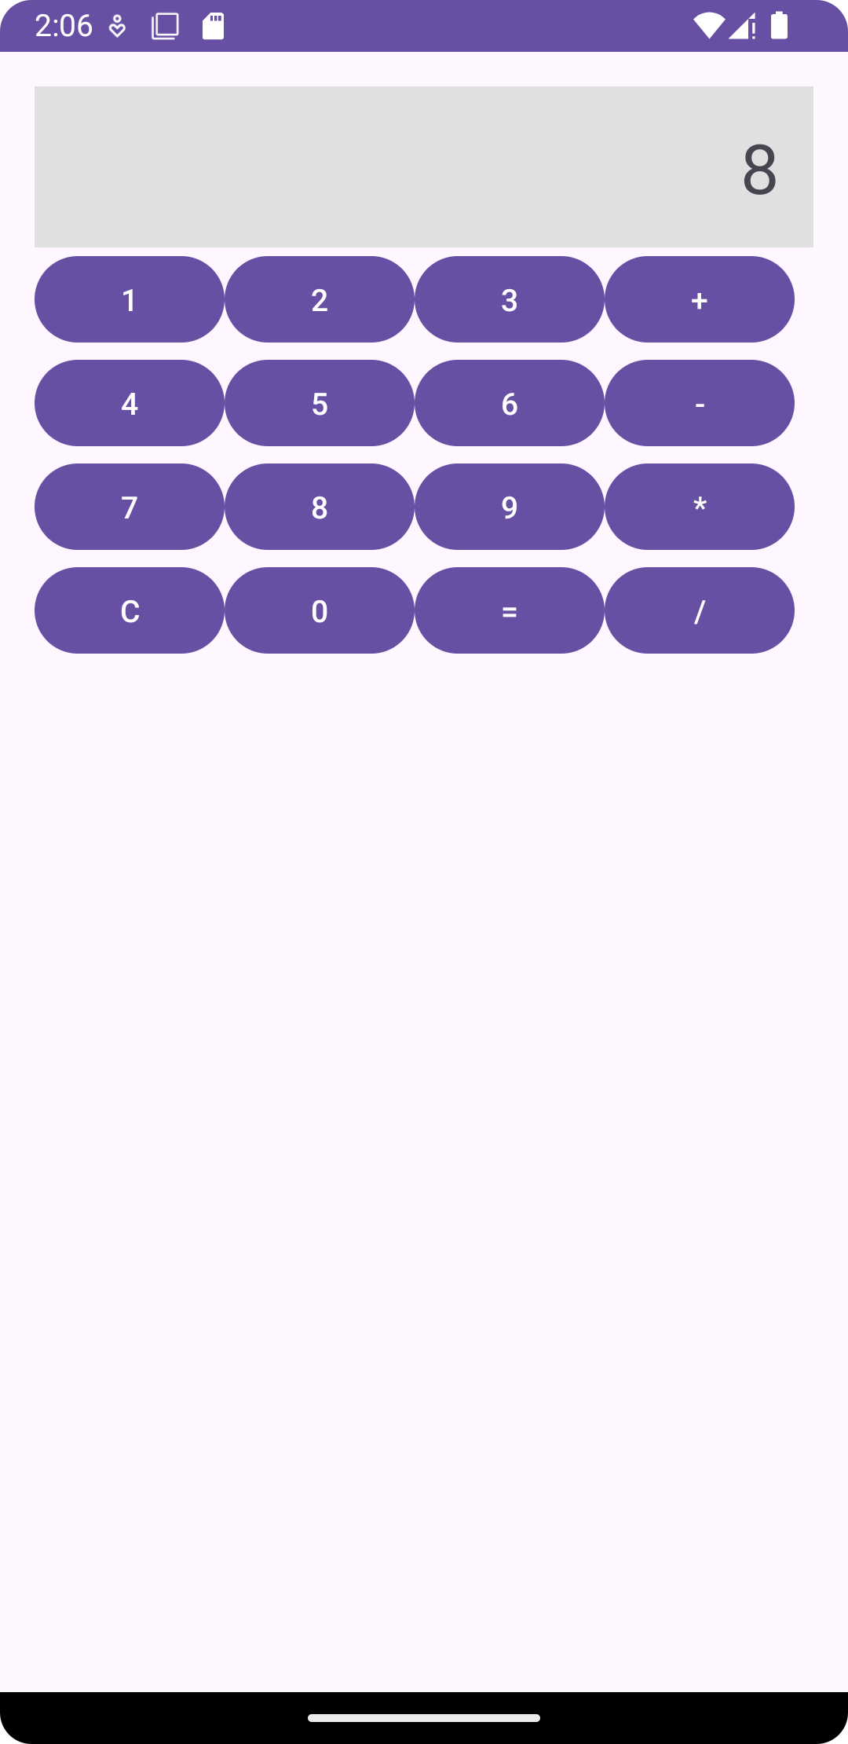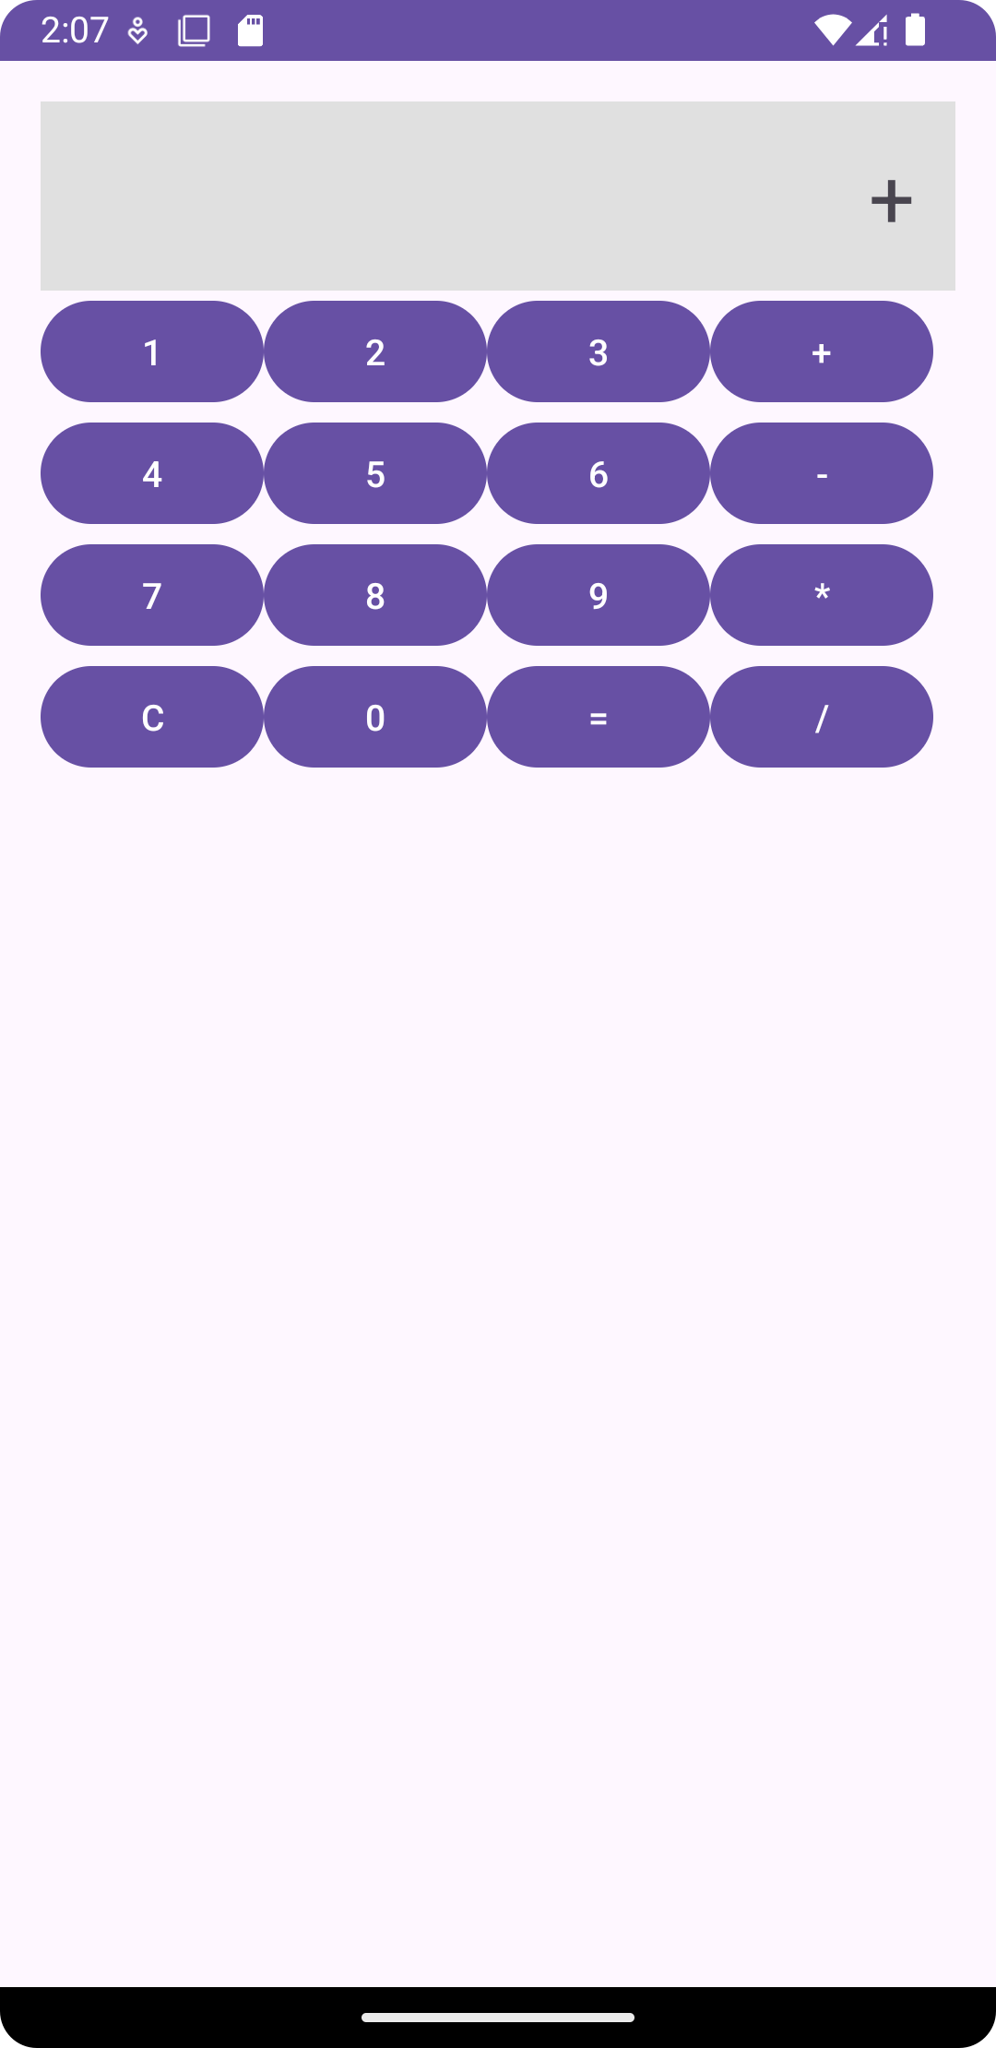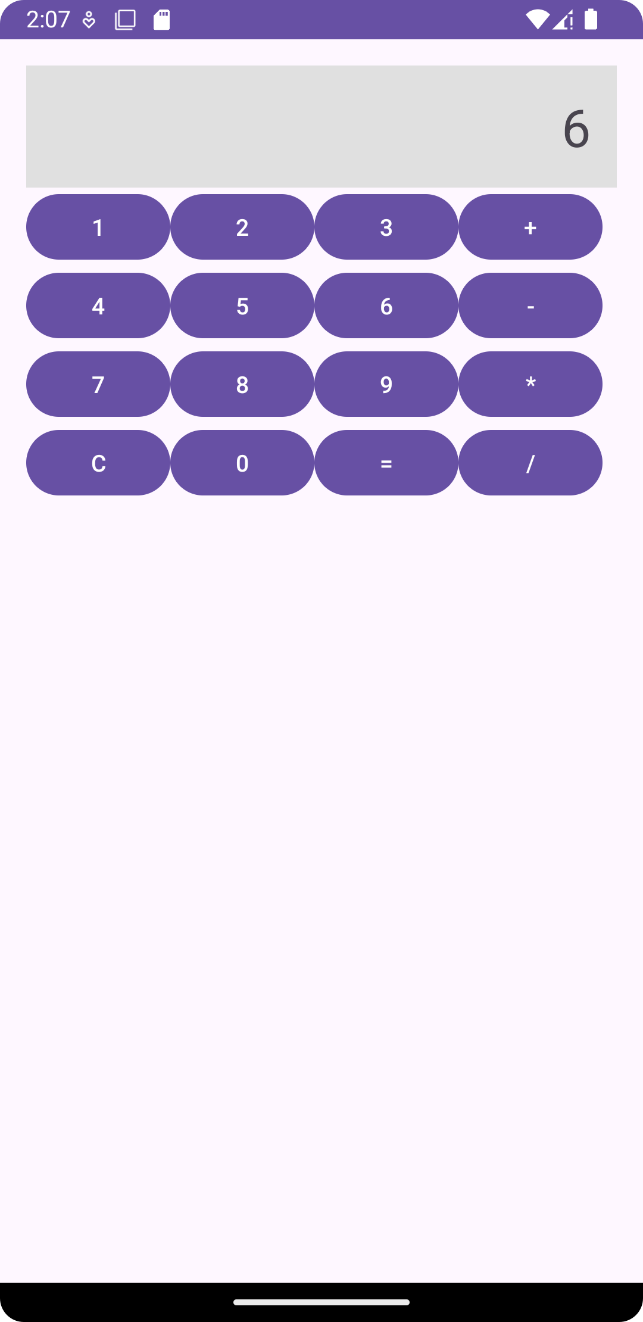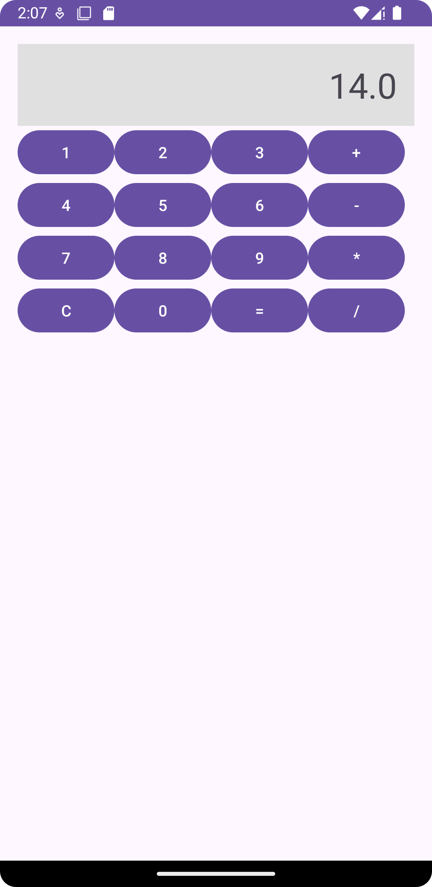

PROGRAM NO:

DATE:

AIM Create a FaceBook page using Relative Layout; Set properites Using.xml file

Xml

<?xml version="1.0" encoding="utf-8"?>  
<LinearLayout xmlns:android="http://schemas.android.com/apk/res/android"  
 xmlns:app="http://schemas.android.com/apk/res-auto"  
 xmlns:tools="http://schemas.android.com/tools"  
 android:layout_width="match_parent"  
 android:layout_height="match_parent"  
 android:background="#3F51B5"  
 android:orientation="vertical"  
 tools:context=".MainActivity">  
 <LinearLayout  
 android:layout_width="match_parent"  
 android:layout_height="wrap_content"  
 android:orientation="horizontal" />  
 <RelativeLayout  
 android:layout_width="match_parent"  
 android:layout_height="144dp">  
  
 </RelativeLayout>  
 <LinearLayout  
 android:layout_width="match_parent"  
 android:layout_height="90dp"  
 android:orientation="horizontal">  
  
 <ImageView  
 android:id="@+id/imageView3"  
 android:layout_width="wrap_content"  
 android:layout_height="wrap_content"  
 android:src="@tools:sample/avatars" />  
 </LinearLayout>  
 <LinearLayout  
 android:layout_width="match_parent"  
 android:layout_height="wrap_content"  
 android:orientation="horizontal">  
 <EditText  
 android:id="@+id/editTextText"  
 android:layout_width="wrap_content"  
 android:layout_height="wrap_content"  
 android:layout_weight="1"  
 android:ems="10"  
 android:hint="Username or Email"  
 android:inputType="text"  
 android:textColor="#FFFCFF"  
 android:textColorHint="#FFFEFE" />  
  
 </LinearLayout>  
 <LinearLayout  
 android:layout_width="match_parent"  
 android:layout_height="35dp"  
 android:orientation="horizontal" />  
 <LinearLayout  
 android:layout_width="match_parent"  
 android:layout_height="wrap_content"  
 android:orientation="horizontal">  
 <EditText  
 android:id="@+id/editTextText3"  
 android:layout_width="wrap_content"  
 android:layout_height="wrap_content"  
 android:layout_weight="1"  
 android:ems="10"  
 android:hint="Password"  
 android:inputType="text"  
 android:textColorHint="#FFFFFF" />  
  
 </LinearLayout>  
 <LinearLayout  
 android:layout_width="match_parent"  
 android:layout_height="52dp"  
 android:orientation="horizontal"></LinearLayout>  
 <LinearLayout  
 android:layout_width="match_parent"  
 android:layout_height="wrap_content"  
 android:orientation="horizontal">  
 <Button  
 android:id="@+id/button"  
 style="@style/Widget.AppCompat.Button.Colored"  
 android:layout_width="wrap_content"  
 android:layout_height="wrap_content"  
 android:layout_weight="1"  
 android:minWidth="30dip"  
 android:text="Log In"  
 android:textColorHighlight="#213AC6"  
 android:textColorLink="#1530C3" />  
 </LinearLayout>  
 <LinearLayout  
 android:layout_width="match_parent"  
 android:layout_height="86dp"  
 android:orientation="horizontal"></LinearLayout>  
 <LinearLayout  
 android:layout_width="match_parent"  
 android:layout_height="wrap_content"  
 android:orientation="horizontal">  
 <TextView  
 android:id="@+id/textView3"  
 android:layout_width="wrap_content"  
 android:layout_height="wrap_content"  
 android:layout_weight="1"  
 android:text="Sign up for Facebook"  
 android:textAlignment="center"  
 android:textColor="#ECE0E0" />  
 </LinearLayout>  
 <LinearLayout  
 android:layout_width="match_parent"  
 android:layout_height="match_parent"  
 android:orientation="horizontal">  
 <TextView  
 android:id="@+id/textView4"  
 android:layout_width="wrap_content"  
 android:layout_height="wrap_content"  
 android:layout_weight="1"  
 android:text="Forgot Password"  
 android:textAlignment="center"  
 android:textColor="#EFE6E6" />  
 </LinearLayout>  
  
</LinearLayout>

Output

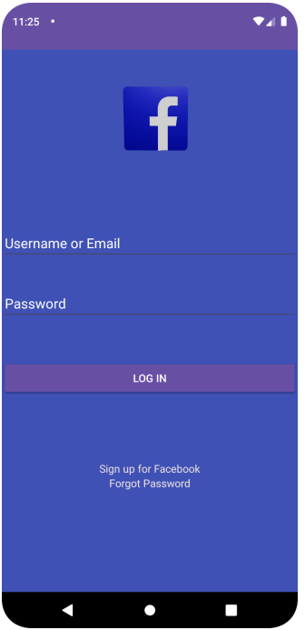

PROGRAM NO:

DATE:

AIM Develop an application that toggles image using Frame Layout